Working Flexibly Policy & Procedure – 6 Month Policy Review

Policy Principles

Our ways of working are becoming increasingly flexible, with growing numbers of employees working from home or other locations, working part-time and varied hours, and we recognise the many benefits of agile working practices. Overall, we value flexibility as it supports us to meet individual and service requirements, which in turn improve the service we offer to our customers and residents. It also allows us to look at alternatives to reduce travel time and increase efficiency.

Although the nature of some roles within the council cannot be completely flexible due to the service requirements, we encourage managers to consider flexible working practices to effectively deliver their services.

This can also support managers and staff to consider how flexible working options can support their ability to flexibly adapt to changes in working practice and service needs.

Policy changes now in place since the policy launch

- Right to request flexible working from day one of employment.
- Flexibility for management to consider more than one flexible working request within 12 months if the service wishes to consider it.
- Removal of flexi-time scheme (with time off in lieu available if required).
- Homeworking requests can now be made for any reason.
- Career break scheme removed, and sabbatical extended from six months to twelve months.

Feedback following the policy launch

General
- Low numbers of queries received (18 in total), of which questions were largely routine and procedural queries
- Positive feedback received on the number of flexible working options available
- Negative feedback centred around the removal of the flexi scheme, in response to which advice was provided on the application of time off in lieu
- Positive feedback received from the delivery of the working flexibly briefing as shown below

Trade Union Survey

Unison conducted a staff survey to understand views from their members on the updated working flexibly policy. Unison confirmed that approximately 40% of their members (non-schools) participated in the survey. A summary of the key points is as below:
- The ability to work flexibly may be dependent on the attitude of the manager, which led to the perception of inequality of opportunity to work flexibly.
- It was felt that time off in lieu was not being utilised satisfactorily, particularly for those that were using flexitime previously.
- Flexibility on where you work appears to be the most common improvement although 16% said that they believe their role is denied this flexibility.
- When you work is the second most common improvement although 30% said that they believe their role is denied this flexibility.
The survey results showed:
- The updated policy had an overall approval rating of 5.12 (out of 10), and in relation to the management attitudes/approach to the updated policy the approval rating was 4.43 (out of 10).
- 12.78% of respondents had made a flexible working request under the new policy. 73.33% of those applicants had their flexible working request agreed by management.
- 3.64% of respondents had experienced an employer led flexible working request under the new policy.

Respondents were asked what the benefits were to the new policy:

Answer Choices |  |  | Response Percent
1 | Better work life balance |  | 57.47%
2 | Helps with caring responsibilities |  | 33.48%
3 | Helps with health (eg reasonable adjustments, disabilities, managing health conditions) |  | 37.56%
4 | Greater flexibility |  | 45.25%
5 | Choice of when and how to work |  | 33.48%
6 | Don't know |  | 18.55%
7 | None |  | 11.76%
8 | Other (please specify): |  | 13.12%

- A good proportion of respondents said their work/life balance had improved, that the policy has supported staff with caring responsibilities, has supported staff managing health/disabilities and has afforded greater flexibility

Respondents were asked what are the problems with the policy?

Answer Choices |  |  | Response Percent
1 | My job does not allow for flexibility |  | 25.95%
2 | Managers attitudes to flexible working |  | 47.03%
3 | TOIL not recorded/granted |  | 25.41%
4 | Removal of flexi time |  | 42.16%
5 | Other (please specify): |  | 15.68%

- As above the main issues centre around management attitudes and the removal of flexitime.
- The survey showed that 68.95% of respondents were not affected by the removal of the flexitime scheme. The 31.05% of respondents who said they were affected said that they felt the main issue was an inability to reclaim additional hours worked and a lack of flexibility. This may suggest that time off in lieu is not being utilised correctly (if the additional hours are required owing to business need).
Overall, it demonstrated further work could be undertaken to embed the policy and ensure that management understand the policy and how it can be applied for both the benefit of the service and employee experience.

Staff / manager stakeholder engagement

Returning to the workplace pulse survey

In the recent returning to workplaces pulse survey for employees and managers the response was positive regarding the ability to work in a more flexible way:

Employee survey
- It was very encouraging to see that 23% of staff were already working flexibly before the policy and procedure was launched and 61% of staff were able to carry out their role in a more flexible way after the launch of this policy in Nov 2021.
- It was also surprising to see that 6% of staff had no support to carry out their role in a flexible way and 4% were not sure on this matter. Also, it was helpful to learn that for 6% of staff, flexibility did not apply to their role and reinforces our understanding that “one size does not fit all”.

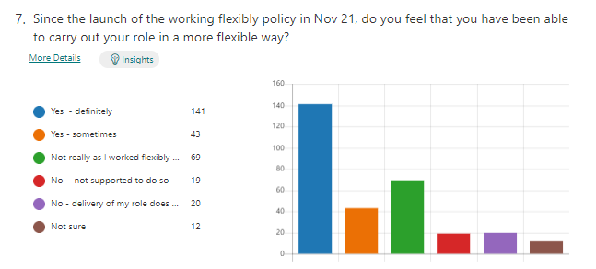
Manager survey
- It was very encouraging to see that one third of managers and their teams were already working flexibly before the policy was launched and 62% of managers were able to support their teams to deliver their service in a more flexible way after the launch of the policy in Nov 2021. 16% of managers have also seen an increase in requests to work more flexibly.
- Only 6% of managers felt they were unable to support their teams with working flexibly practices as there are service delivery constants not conducive to apply this policy in practice.
- 17% of managers reported seeing an increase in flexible working requests.
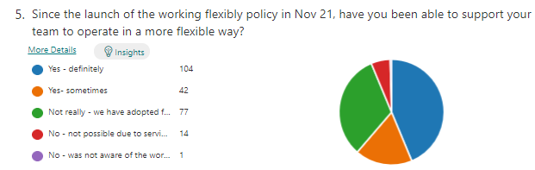
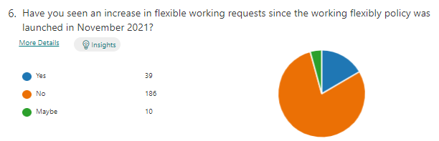

Feedback from leadership and management sessions

Between January and April 2022, the Skills, Learning & Development service asked delegates participating in leadership and management training sessions to provide their views on the working flexibly policy and whether this has supported their services in their delivery and benefited their staff. Their responses in summary were as follows:
- Managers felt they had embraced working flexibly throughout the last 2 years and recognised that staff had adapted their home life around this.
- It was seen that some staff felt they found working from home more productive, and in one case life changing as they struggled to commute owing to their disability.
- Generally positive response about being able to informally allow flexibility around start and end times to the day to meet caring needs.
- Managers felt the application of the policy will help with recruitment and retention.
- Delegates advised there is also a requirement to focus on business need.
- Managers spoken to had generally not seen an increase in flexible working requests.
- Staff understand the policy and understand the procedure involved in making flexible working requests.
- Small number of staff had raised they felt they had lost out on the ability to accrue 18 flexi days. Generally, it was felt that the culture had changed around time off in lieu in terms of it being service led as opposed to employee led and this was seen as a positive from a management perspective.
- Some managers needed to reinforce to staff to take regular breaks.
- Some managers felt they needed structured rules to apply flexibility.

Feedback from manager stakeholder group

A manager stakeholder group was conducted on 18th May 2022, and the feedback received is as follows:
- There has been an increase seen in working flexibly requests, particularly around compressed hours.
- Consistency of application of working flexibly practices may vary from manager to manager.
- It was felt that guidance could further endorse business needs.
- The participants advised they believed that it was a good opportunity to reset the culture around accruing working time from being employee led to service led. They shared it was good to have the ability to flex when time can be taken back to suit the individual and service, however there was a suggestion that a cap is applied so that individuals are unable to accrue too much time off in lieu. Time off in lieu is felt to be preferable to using casuals to cover (due to the experience of existing staff) and it is seen as a good retention tool.
- Front line services find applying flexibility challenging.
- Managers are generally seeing increased productivity as a result of working flexibly and further ability to work remotely in some services, saving time on commute which may mean more access for service users to our staff.

Recommendations / actions

The below sets out the recommendations and actions identified as a result of the review following input from stakeholders, the trade unions, and the data review.

The below actions will allow us to further embed the policy within the council and enhance further the working flexibly guidance.

- Offering hosted training for managers on the updated policy and procedure.
- Enhance the working flexibly guidance for managers around dealing with flexible working appeals
- Update guidance surrounding care for dependants to give further clarity on how this should be considered and how it links into other policies and procedures.
- Consider communication methods to further embed the policy principles, alongside the work being undertaken by the working flexibly board.
- No proposed changes to the working flexibly policy and procedure.

Wider Developments

Whilst the review was for a specific purpose as part of the consultation with the trade unions, since that time developments have taken place that consider the wider impact of flexible, agile and hybrid working arrangements to meet business needs. In addition, strategic workforce priorities have developed that will further focus on delivery of a people strategy, the aim of which is to fully ensure we work in a way that will actively deliver our priorities and enable our council to meet the needs of our residents.

